**ITA0448 – STATISTICS WITH R PROGRAMMING FOR VECTORIZED EXPRESSIONS**

**SUBMITTED BY: DEVADARSHINI J REG NO: 192124092**

**DATE: 21/03/2023**

**SET 1**

1. **Will the following code return any error? State the reason behind your answer and explain the logic behind the code :**

**val <- numeric()**

**result <- vector("list", length(val))**

**for (index in 1:length(val)) {**

**result[index] <- val[index] ^ 2**

**}**

**Sol:**

The given code will not return any errors, however we may not achieve the desired output because the val function is empty. Hence the loop will not iterate at all.

1. **What is the value of equation1(3) for the following R code and explain the logic.**

**num <- 4**

**equation1 <- function (val)**

**{**

**num <- 3**

**num^3 + g (val)**

**}**

**equation2 <- function (val)**

**{**

**val*num**

**}**

**}**

**Sol:**

The given code defines two functions equation1 and equation2 , and sets the value for the variable num to 4. If we call equation1(3), it will first set the local variable numto 3 within the function. Then it will calculate num^3, which is 27. It will then call a function g() with val as its argument, and add the output of g(val) to 27. But, since the implementation of g() is not given, we cannot determine the exact output of “equation1(3)”.

1. **Write R function to find nth highest value of a vector in the R program**

**Sol:**

nth_highest <- function(vec, n) {

if(n > length(vec)) {

stop("n exceeds length of vector")

}

sorted_vec <- sort(vec, decreasing = TRUE)

sorted_vec[n]

}

1. **Explore the air quality dataset. It contains daily air quality measurements from New York during a period of five months:**

**• Ozone: mean ozone concentration (ppb),**

**• Solar.R: solar radiation (Langley),**

**• Wind: average wind speed (mph),**

* **Temp: maximum daily temperature in degrees Fahrenheit,**

**• Month: numeric month (May=5, June=6, and so on),**

**• Day: numeric day of the month (1-31).**

**i. Compute the mean temperature(don’t use build in function)**

**ii. Extract the first five rows from airquality.**

**iii. Extract all columns from airquality except Temp and Wind**

**iv. Which was the coldest day during the period?**

**v. How many days was the wind speed greater than 17 mph?**

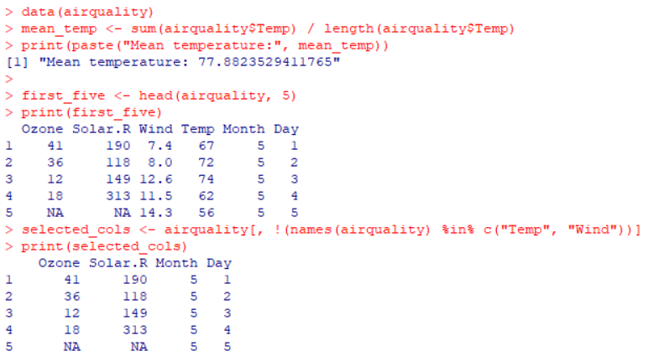

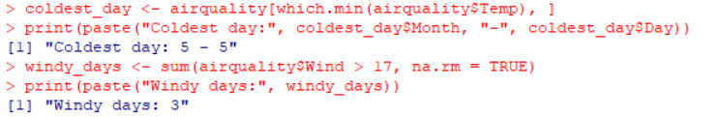

**5. Write R Program to find maximum and minimum value of a given vector using control**

**statement.**

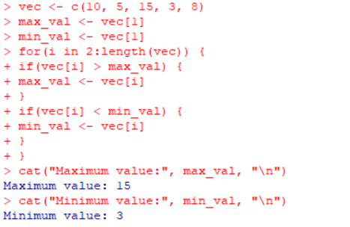

**SET 2**

1. **Create the following matrices (i) Square Matrix (ii) Identity Matrix (iii)diagonal matrix**

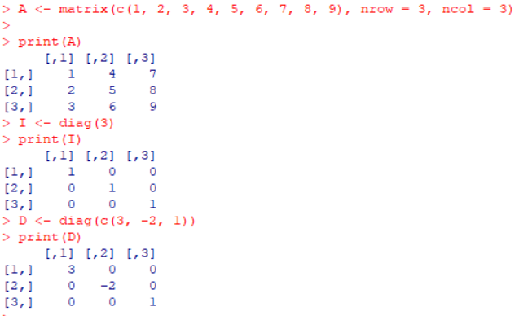

1. **Using sapply, check that all elements of the list are vectors of the same length. Also calculate the sum of each element.**

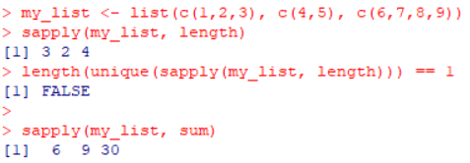

1. **We found out that the blood pressure instrument is under-recording each measure and all measurement incorrect by 0.1. How would you add 0.1 to all values in the blood vector?**

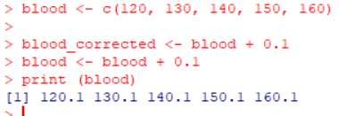

1. **We found out that the first patient is 33 years old. How would you change the first element of the vector age to 33 years?**

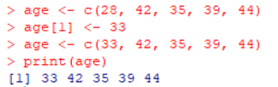

1. **Suppose A = [ 1 1 3 5 2 6 −2 −1 −3 ] (a) Check that A 3 = 0 where 0 is a 3 × 3 matrix with every entry equal to 0. (b) Replace the third column of A by the sum of the second and third columns**

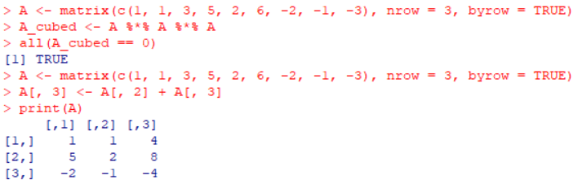

**SET 3**

1. **The numbers below are the first ten days of rainfall amounts in 1996. Read them into a vector using the c() function**

**1.1 0.6 33.8 1.9 9.6 4.3 33.7 0.3 0.0 0.1**



1. **What was the mean rainfall, how about the standard deviation?**

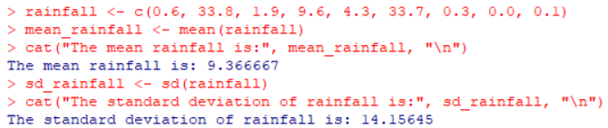

1. **Which day saw the highest rainfall (write code to get the answer)?**

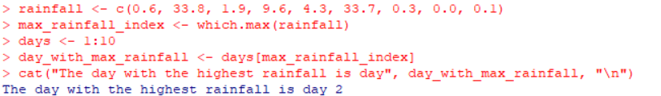

1. **The 26 letters of the Roman alphabet are conveniently accessible in R via letters and LETTERS. These are not functions, but vectors that are always loaded. What is the 18th letter of the alphabet?**

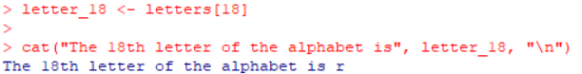

1. **What is the last letter of the alphabet (don’t guess, write code)**

